**

MICROCHIP IMPLANT MANUAL

Cats / Dogs



Dear New Learner,

When you have been successfully trained to microchip with us please make sure you take advantage of our free advertising for any animal related business on the Peddymark.com website, it’s easy to use, simple to navigate and it’s free.

All you need to do is go to:

[**www.peddymark.com**](http://www.peddymark.com/)

Select ‘My Account’

Fill out your details and create an account

On the main page you will see this section:

Click on the button and fill out your details for your advertisement

PeddyMark will then be notified that you want to advertise and a member of staff will activate your account. If you have any problems please don’t hesitate to contact us. Thank you for choosing PeddyMark.

Yours sincerely

Caitlin Pearson

Training Coordinator for PeddyMark Ltd

[**www.peddymark.com**](http://www.peddymark.com/)[**e-mail:info@peddymark.com**](mailto:info@peddymark.com)

VAT Reg. 836447702

**MICROCHIP IMPLANT MANUAL**

# SECTION 1

1. ***ANIMAL IDENTIFICATION***

Microchip technology for animal identification was first introduced in the 1980s and has developed over the years into the injectable chip or transponder used today. Veterinary surgeons, animal welfare groups, animal wardens, breeders and trained implanters now routinely use microchips worldwide to identify animals. The microchip provides permanent proof of identification without any form of scarring or disfigurement and is now used widely as a scheme to reunite lost and found pets with their keepers.

There are many different circumstances which may require animals to be permanently identifiable, such as the Pet Travel Scheme, Tail docking, Compulsory Microchipping of Dogs Act (including Cats for England) and various Health Schemes. Microchipping provides the best and sometimes only acceptable form of identification in these circumstances, however, it needs to be remembered that the microchip is of little use if it isn’t registered correctly and pet keepers need to be made aware of their responsibility to keep their pet’s details up to date.

# HOW DOES IT WORK?

***Radio Frequency Identification Devices or RFID***. Microchip technology is based on the use of scanners sending out a radio wave or electromagnetic field. When a scanner comes into proximity with a chip, the chip is energised by the radio wave and transmits its unique code back to the scanner.

The scanner LCD will then display the microchip number.

The scanner does all the work, the microchip is passive and has no independent power supply of its own!

# WHAT IS A MICROCHIP?

Our microchips come in three sizes 12mm x 2mm, 10mm x 1.4mm & 8mm x 1.4mm.

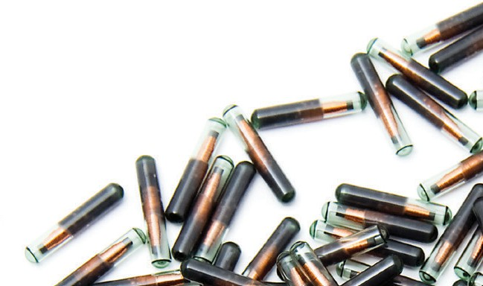They are encased in biocompatible glass and conform to ISO standards 11784 and 11785. PeddyMark recommend that the 8mm x 1.4mm (mini) microchip only be used in cats, small mammals and breeds of dog not exceeding approximately 15kg adult bodyweight.

The other two sizes are suitable for and can be used in all companion animals.

Each chip is pre-programmed with its own individual 15 digit number. The chip is totally passive, it is not until the energy from the low frequency radio wave from the scanner is passed over the chip that it becomes active. The unique number of the microchip then appears on the display of the scanner. The first three digits of the microchip number relate to the manufacturer code and aid in the backtrack process enabling the supplier of the microchip to be quickly identifiable. In some countries a country code is used, however this isn’t currently used in companion animals in the U.K.

# THE SCANNER

There are various types of microchips on the market, 10 digit numbers ISO FDXA and 15 digit ISO FDXB, all of which can be read by ISO compliant scanners. All microchips being implanted now should only be of the ISO FDXB standard, however, there may still be older animals with the FDXA microchips implanted in them.

There are several makes of scanner on the market, so it is important to check the scanner you are using is of the ISO standard 11785 and can read both the above standards FDXA and FDXB. All the scanners offered by PeddyMark Ltd will always be of this standard unless otherwise stated.

Scanners come in various different makes and models. They all operate in slightly different ways, yet all have the same basic function – that of reading and displaying the microchip number.

# USING A SCANNER

Scanners may work differently so turn the scanner on and select scanning mode as directed by instructions for individual scanner. If the scanner is new to you or hasn’t been used for a while it is a good idea to test it first on a functioning microchip to ensure it is reading correctly and that you are familiar with how to use it.

Hold the scanner with the side where the coil is housed facing the animal. The coil is the part of the scanner where the radio frequency waves are emitted.

You need to have the scanner in close proximity to the coat to ensure it will pick up the microchip.

Begin scanning ***SLOWLY*** over the animal’s implant site using small circular motions around the shoulder blade area for dogs and cats.

## Continue scanning the animal all over the body. If the chip is not detected in the normal site, it is possible the microchip could have migrated. Scan the animal thoroughly prior to microchipping to ensure there is no chip present.

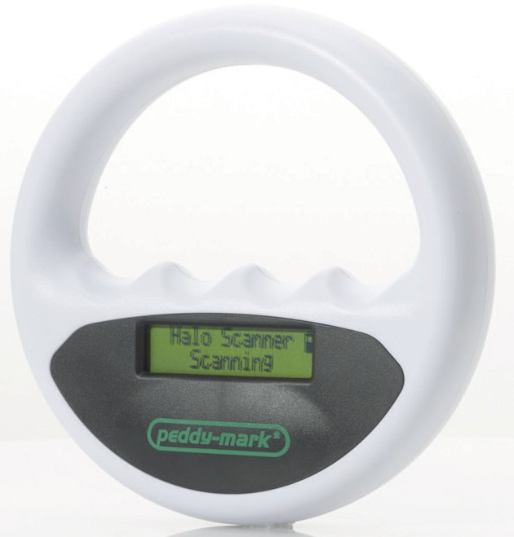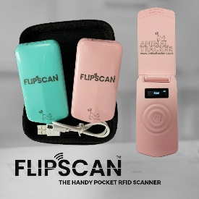

Environmental conditions may have an effect on how well a scanner performs, for example if you are scanning an animal on a metal table the radio waves may bounce off the table and cause an inaccurate reading. Other things to consider are other electrical items that use radio frequency waves that may cause interference such as microwaves. Extra hot or extra cold temperature conditions may also have an adverse effect on the scanner.

It is also advisable to ensure there aren’t any other microchips in close proximity to where the scanning is taking place to prevent the wrong microchip being scanned accidentally.

It is important to ensure the scanner either has enough charge for use or that the operator has a spare battery in case it runs out during the procedure. Scanners should be cleaned as necessary with wipes or a damp cloth after use and stored in a safe place to prevent them from being dropped or damaged.

If you are having problems with your scanner, checking all these things should aid you to troubleshoot any problems. If you are still unhappy with how your scanner is functioning seek the advice of your supplier.

# SECTION 2

1. ***SCANNING OF DOGS AND CATS AND OTHER SMALL MAMMALS***

The microchip site for dogs, cats and other small mammals should be right on the middle of Zone A (mid scapulae) – coloured in red below. This is the recognised site for implantation in the UK, however in some European countries slight differences in implantation site may be practiced, therefore it is most important before microchipping any animal that you also scan Zone B – left flank, Zone C – right flank, and Zone D – the rest of the body.

# MIGRATION

Microchips have been known to migrate. This can occur either through poor implant technique, poor restraint, a combination of both or interference with the injection site too soon after implantation. Animals microchipped whilst under some form of sedation have often been known to suffer from migration as well. For these reasons it is important to scan the animal thoroughly as described in section 1E.

When using the scanner, ensure you move the scanner slowly over the coat in small, slow, circular motions, to allow time for the microchip to respond to the signal sent by the scanner. If you attempt to scan too quickly you may simply miss the microchip altogether.

***Please note it is very important to continue scanning the animal all over the body if the chip is not detected in the normal site.***

# SECTION 3

1. ***MICROCHIPPING PROCEDURE***
   1. Before attempting to microchip any animal, you **must always** scan it thoroughly all over to ensure that it has not been previously microchipped. The person bringing the animal to you to be scanned/ microchipped may not be aware the animal already has a microchip. Stolen or lost animals have been identified at this point.

When the scanner picks up a microchip it will give an audible beep and the 15 digit number will be displayed in the scanner LCD. If a chip is already present **DO NOT** attempt to re-chip the animal. Inform the keeper of this fact and use the [**checkachip.com**](https://www.checkachip.com/microchipsearch/) website to find the database the chip is registered to. Provide the keeper with the databases contact number so they can complete the registration.

If you have scanned the animal all over its body and have not detected a microchip, it is now safe to continue.

Ensure that before you microchip the animal that you have the keepers’ informed consent to go ahead. The keeper should be made aware of what is involved in the procedure and how and where their details are going to be recorded (on a DEFRA compliant database and by the implanter, not to be used for any other purpose other than reunification of animal with its keeper). This should also include making the keeper aware of the cost of the procedure as well as the cost to register on the database. The Implanter should keep a copy of informed consent with implant details keeping information confidential in accordance with the Data Protection Act (2018). These records should not be used in any way other than to assist in the reunification of the animal with its keeper.

Microchipping, particularly dogs and cats, is a simple straightforward subcutaneous injection. ***However, evidence amassed over the last 10 years proves conclusively that implant site and technique are crucial to the stability of the chip on site and the prevention of adverse reactions.***

* 1. Prior to microchipping any animal, it is very important to assess the animal on an individual basis to determine if it is suitable to be microchipped. Any signs of ill health should be recognised as this may mean it isn’t appropriate to chip at this time. For example, if the animal is currently suffering from some sort of skin complaint it may be necessary to leave and return once the infection has cleared. It can also be advisable when obtaining informed consent from the keeper to request the animals’ vaccination record to check all inoculations are up to date and ask the keeper if there are any health issues which may affect whether or not the animal is suitable for implantation. If for any reason the health of the animal causes you concern that would prevent you from carrying on with the implantation, you should advise the keeper to refer to a veterinary surgeon for further advice.

Assessing the animals’ behaviour is also important. The keeper should know how the animal has previously reacted to different situations and be able to give their advice on whether or not the animal is likely to be scared or aggressive and if muzzling is required. The implanter should also be competent at recognising signs of fear, aggression, pain or distress. In the case of microchipping animals at rescue shelters this could be discussed with staff or veterinary records should be available. Dogs that have reached 8 weeks but are not considered to be suitable due to poor health will require a veterinary exemption certificate stating that their microchipping should be left until a certain age due to health status, in order that the keeper is still complying with the law. This also applies to cats if they have reached 20 weeks.

# IMPLANTATION PROCEDURE

* 1. Ensure you have a clean, safe environment to work in and that you have all the necessary equipment and paperwork before proceeding. Make sure others working in the area know you are microchipping and do not inadvertently disrupt you.
  2. Firstly verify the sterility of the chip packet. The sterile packet typically contains the needle, microchip and spacer within the needle. It is vital that the sterility of the packaging has not been compromised in any way to prevent the risk of infection. You should also ensure the sterilisation date has not been exceeded.
  3. Scan the microchip before opening the packet and confirm that the number matches the bar code. Please note that as you are scanning the microchip through metal it may take longer for the scanner to recognise the microchip and that the read range will be affected by the metal of the needle. This process checks that the microchip is functioning correctly and that the number matches that shown on the bar code labels. It also acts as a double check that the scanner is functioning correctly. If a microchip is found to either not be working or not match the bar code provided you should report this back to the supplier as soon as possible so they can take appropriate action. Failure to check microchips prior to implanting could lead to a non-functioning chip being inserted which would be detrimental to the animals’ welfare as it would have to go through the whole procedure again.
  4. Remove the needle from the packet and if appropriate, attach to a gun. Ensure that the bevel of the needle is facing you. This will ensure that the bevel enters the animal at the correct angle so as not to tear the skin.

# IMPLANT SITE FOR DOGS/CATS AND OTHER SMALL MAMMALS – SUBCUTANEOUS MID SCAPULAE

* 1. The microchip should sit midline in between the scapulae (shoulder blades) after implantation and NOT in the back of the neck or scruff!
  2. It is not recommended to implant a chip while the animal is under sedation or asleep. Awake, sitting and gently restrained is best and will help avoid migration of the microchip. Ask the assistant to restrain the animal. (An assistant is best as a keeper is not always the most appropriate person to restrain the animal). Never attempt to chip an animal without someone restraining it. There are different methods of restraint for different species which will be explained and demonstrated during your practical training appropriate to the species you are using.
  3. Sterility of implant site.

It is very important to ensure that the implant site and the implanter’s hands are clean or surgical gloves are worn to help prevent any likelihood of infection of the site after microchipping.

You can:

* + 1. Check the area thoroughly for any signs of dirt and remove any loose hair, make sure that the sterility of the needle is intact and that the sterilisation date on the packet has not expired. As long as you are confident that the animal is healthy, the site is clean, and asepsis is maintained throughout, you may proceed with the microchipping.

Or

* 1. While visibly clean skin may appear sufficient, it does not guarantee that the skin can maintain asepsis throughout the procedure, you may wish to use an alcohol base sterilisation fluid and administer to the implant site with a cotton pad. Please be aware that this will cause the animal more discomfort than without as once the skin is broken with a 12g needle there is every chance any residual alcohol will seep into the wound stinging, or smarting the animal, which may then lead to sudden and unexpected movement at a crucial stage during the microchipping implantation. It is important that the handler restraining the animal and the implanter carrying out the microchipping are aware of this.

It is important to ensure the implant site is clean and disinfected as this will help to prevent any infection. It will also promote healing and help avoid any adverse reactions.

* 1. The entry point of the needle is just beneath your index finger at an angle of about 20 degrees. It is important that you chip towards the animal’s head and only expel the chip when the needle is between the scapulae. ***The pinch of skin you take up should be at right angles to the spine, across the back of the animal, just behind the shoulder blades.*** Take hold of the skin just behind the shoulder blades using your middle finger and thumb. Lift and pull up the excess skin creating a pocket with your index finger facing towards the tail and then insert the needle immediately below your index finger.
  2. Using firm constant pressure with the implant gun, insert the needle into the animal, below your index finger. The shape of the needle makes a small cut in the skin allowing the needle to pass through. Be aware that some breeds or older animals may have tougher skin than you have encountered before and therefore may require more pressure. Insertion of the needle may cause momentary pain and some animals may also jump slightly or vocalise. The implanter should continue with the procedure quickly and smoothly to avoid having to attempt it again.

Once the needle has reached the subcutaneous cavity (a few millimetres past the bevel) activate the plunger/trigger of the implantation device to push the spacer in the needle thus implanting the chip into the animal just below the top layers of skin into the subcutaneous layer/space. It is important to maintain asepsis throughout the procedure to minimise the risk of infection. Never touch or put an unsheathed needle down on any surface or attempt to use a needle more than once if implantation unsuccessful.

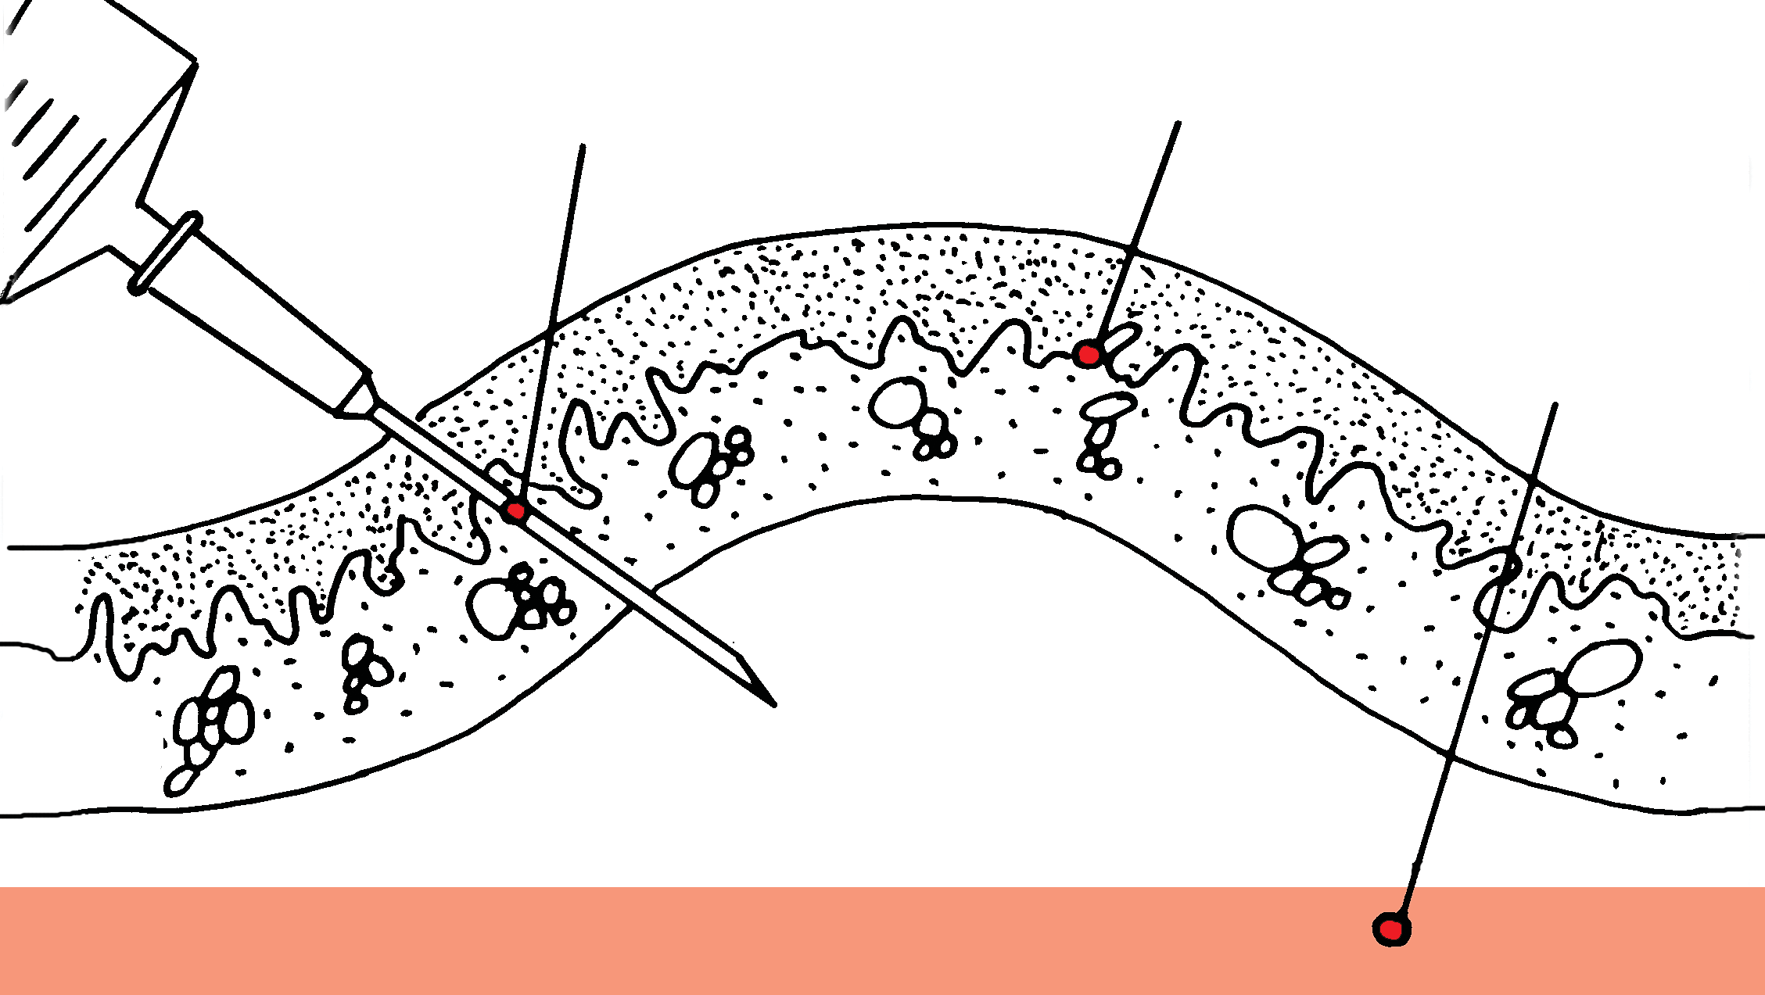

Needle

Lift Skin

Muscle

Subcutaneous Space

1. When extracting the needle from the animal it can create suction. This can sometimes lead to the chip being pulled back out with the needle. ***To prevent this, ensure that you MOVE YOUR FINGER AND THUMB and pinch the skin around the needle whilst inside the animal when you withdraw it, effectively milking the chip away from the tip.*** When the needle has been removed apply finger pressure on the entry site for a few seconds. In some cases, there may be a small amount of bleeding due to a capillary in the skin being caught by the needle. In this instance simply apply pressure on the wound with a ball of cotton wool, until the bleeding ceases. Never rub the wound as this may cause the microchip to move/migrate.

## Moving your fingers around the needle and pinching the skin upon withdrawal ensures the chip leaves the needle, is implanted in the animal at the correct depth and is retained within the animal and does not pop out at some stage after implant.

Dispose of the needle immediately and safely into a sharps container and treat as clinical waste for incineration. ***Never attempt to re-sheath needles***. Contact the Waste Department of your local council for the best method to dispose of sealed sharps bins in your area. Failing this contact PeddyMark for further advice.

1. It is important that you now scan the animal to confirm that the chip is safely in place and functioning and fill out either the online or paper registration form. ***Check the implant site to ensure the chip is under the skin and not sitting in the coat!*** (Particularly in the fur of long haired breeds).
2. Explain to the keeper that the implant site will be sensitive for a while and that they must keep the animal as calm as possible (i.e. no rigorous exercise), they ***must not*** try to feel for the microchip as either of these could cause it to move from the implant site and prevent the chip adhering to the surrounding tissue. It could also introduce infection into the wound. Grooming the animal, excessive exercise, use of a harness or other items of clothing should be avoided for 12 hours. During handling, the area should be avoided for the next 24 hours. If a lump or swelling appears at the site of infection, veterinary attention should be sought. Implanters should provide the pet keeper with their contact details should they require any advice following implantation.

The above instruction relates to the microchipping of dogs, cats and other small mammals, which is considered a non-veterinary procedure by the Royal College of Veterinary Surgeons. These guidelines also work in accordance with the Veterinary Surgeons Act (1966) and DEFRA guidelines which state that lay implanters may microchip these species provided they have received appropriate training authorised by the Secretary of State.

# SECTION 4

1. ***MICROCHIPPING OF SPECIES OTHER THAN CATS AND DOGS***

***Please note*** the microchipping of any species other than cats and dogs or small mammals such as ferrets and rabbits should ONLY be carried out by a veterinary surgeon. One of the reasons for this is the varying implant sites for different species, some of which are more invasive than others. ***Equines, avians and reptiles are strictly veterinary procedures only.***

It is important that you only work in accordance with the Veterinary Surgeons Act (1966) within the limits of your own authority and experience. If at any time you feel you require assistance, please contact PeddyMark for advice or to arrange refresher training.

Please note that under the Veterinary Surgeons Act 1966, the implantation of a microchip is considered to be an act of veterinary surgery when:

* + Implantation by methods other than the subcutaneous route, ear tag or bolus are used, in view of the potential for pain or stress or for spreading disease, and in some cases the potential handling difficulties.
  + The repair or closure of the entry site requires veterinary surgery.
  + If there is special risk to the health or welfare of the animal.
  + Microchipping horses within the nuchal ligament.

# USING OTHER EQUIPMENT

***Please note*** the training instruction in this manual, along with the training you receive on microchipping courses, will be specific to the individual manufacturer’s equipment. Should you at anytime attempt to microchip with equipment other than that manufacturer’s equipment, you should check training requirements with the alternative supplier. You should be aware that implanting equipment varies from supplier to supplier and you should not assume that all equipment can be operated in exactly the same way.

## Never use a different implant device to the one that was supplied with the microchips you purchased.

If unsure please seek advice from PeddyMark.

# SECTION 5

1. ***REGISTRATION PROCESS***
   1. It is important that any database used for the registering of pet and keeper details meets the requirements of the Data Protection Act (2018).

The registration should be completed online. Microchips for domestic pets should never be purchased without some form of registration to a DEFRA compliant database.

* 1. Keepers should be aware that their details are going to be held on a database that meets the conditions laid out in Section 6 of “The Microchipping of Cats and Dogs (England) Regulations 2023” and “The Microchipping of Dogs (Wales) 2015”, Section 7 of “The Microchipping of Dogs (Scotland) 2016” and Section 9 of “The Dogs (Licensing and Identification) Regulations (Northern Ireland) 2012” and that their details will only be used for the reunification of their pet. They should give their informed consent for their details to be held in this way. This is done by ticking a check box when registering online. Implanters should also have a signed consent form from the keeper confirming their agreement for the microchipping to take place, which they should keep with the registration details.

To register online with Animal Tracker, you will need to create an online implanters account.

Go to animaltracker.co.uk and select ‘Create Account’

Select the option that best applies to you from the drop down and fill out your details.

There will be a box to add your Implanter PIN, this is given to you once you have completed your training. If you do not have your PIN yet, use the temporary number TP999.

Your account will then be added to a list for authorisation.

Once this has been checked over, your account will be ready to use

# ONLINE REGISTRATION

Where microchips are purchased, you will be supplied with a cheque book containing receipts to issue to your clients. You are required to attach two barcodes, one to the receipt and one to the cheque book stub. The chequebook stub is kept for your records. This is important for backtrack purposes.

The perforated receipts make it easy for you to provide the keeper of the animal with something to take away on the day. This document will have the date the microchip was implanted and a copy of their pets’ unique microchip number.

Ensure the keeper checks the details you are going to register the pet against before submitting.

# ENSURE THE KEEPER UNDERSTANDS

* They will receive a transfer code from the database which they will use to complete their registration.
* The importance of keeping their details up to date on the database. It is now their responsibility to keep their details up to date on the database. Make sure the keeper is clear what database their pet is registered on and how to contact them should they need to update their details. They should also be aware that the database may make a charge for subsequent changes depending on their account type.

# SECTION 6 BACKTRACK

Occasionally an animal may be lost prior to completion of its registration. It is therefore essential that you, the implanter, have kept up to date records so that the backtrack system is successful. When a backtrack is required the database concerned will contact the supplier of the microchip to determine the contact details of the person who implanted the animal and in turn contact them directly so they may interrogate their own records for the correct keeper details.

It is therefore important that implanters do not pass on unwanted microchips to other trained implanters/organisations. Implanters should not pass keeper details on to unauthorised persons.

Please contact PeddyMark regarding their buy back scheme to ensure microchips are reallocated accurately. This will ensure the backtrack system works effectively.

We understand that it is not always convenient to register the animal online immediately, therefore we have provided a downloadable online registration form to ensure you capture all the data required to register the details later at a suitable time, but as soon as possible after implantation. This can be found on our website: [www.peddymark.com](http://www.peddymark.com/) in the shop section selling microchips with online registration.

## Please note that any enquiries you may have regarding the registration of an animal should be directed to Animal Tracker either via their website at [www.animaltracker](http://www.animaltracker).co.uk or by contacting them on 01279 219777.

***Section 7***

Peddymark Ltd is a member of the MTA (Microchip Trade Association) and AMDO (Association of Microchip Database Operators). The training supplied by us is approved to the LANTRA standard required by the Secretary of State as stated in relevant legislation laid out in section 7B.

In line with this legislation, it is a requirement that any adverse reactions are reported to the Secretary of State. For this purpose, a reporting scheme has been set up via the VMD (Veterinary Medicines Directorate) with the assistance of DEFRA and the MTA.

1. ***Adverse Events Reporting Scheme***

Should you find it necessary to report any adverse events regarding microchipping, the correct course for reporting is as follows:

Go to: <www.gov.uk/report-veterinary-medicine-problem>

On the home page there is a link titled “Report an Adverse Event”

When you click this link it takes you through to a reporting page and at the top is a notice on Microchip Adverse Reporting. Click on this link, complete the electronic form and submit.

Please note there are only three considered adverse reactions:

* 1. Implantation reactions, - (any pathology that seems to have arisen as a result of implantation, but this should be confirmed by a vet before reporting).
  2. microchip migration.
  3. microchip failure.

There is a PDF form on the site which explains everything in detail if required.

1. ***Legislation and Codes of Practice***

Implanters should make sure they are up to date with any current legislation and Codes of Practice that may apply to them when performing microchipping.

Every implanter should be aware that they have a responsibility to work to appropriate levels of Health and Safety legislation and should undertake their own high standards in their professional conduct.

Implanters must ensure they never work outside of their legally authorised specie areas and should ensure they have their own liability insurance in place, especially when offering this service to the general public.

Implanters should be familiar with the following legislation which may be referred to throughout the manual and training as ‘Relevant Legislation’:

“The Microchipping of Dogs and Cats (England) Regulations 2023.”

“The Microchipping of Dogs (Wales) Regulations 2015” “The Microchipping of Dogs (Scotland) Regulations 2016”

“The Dogs (Licensing and Identification) Regulations (Northern Ireland) 2012”

It is worth noting that a dog or cat will not be considered microchipped unless it is microchipped AND registered. It is the implanters’ responsibility to complete the initial registration, however it is ultimately the new keeper’s responsibility to ensure the pets registration is updated correctly. When a change of keeper occurs, the previous keeper should ensure they give everything required to the new keeper for them to update keeper details on the relevant database.

Under the Control of Dogs Order 1992, it is stated that when out in public it is a legal requirement that dogs wear a collar and tag with the keepers current name and address on it. A telephone number is not a legal requirement but may be very helpful in reuniting any strays with their keepers quickly.

If implanters are offering microchipping on behalf of larger businesses, they must ensure they are up to date with any in-house business policies or guidelines that are in place in addition to current legislation.

Implanters should be aware of the Current Animal Welfare Legislation for their area of the country and ensure they operate in accordance with this legislation at all times:

* England and Wales, Animal Welfare Act 2006
* Scotland, Animal Health and Welfare Act 2006
* Northern Ireland, Welfare of Animals Act (Northern Ireland) 2011

There are many debates around the ethics of the microchipping of companion animals, however statistics show that it remains to be an extremely safe and permanent method of identification which is strengthened by The Microchipping of Cats and Dogs (England) 2023 and other legislation across the UK.

1. ***Follow up advice and refresher training***

If you require any further information or have any queries, please contact Peddymark and one of our team will be happy to help. We offer refresher sessions for anyone who is trained but has not microchipped for a while as

well as further training to implanters who wish to add another species to their competency list.

***Microchipping of Cats and Dogs 2023***

As of 10th June 2024 it is now a legal requirement for cats to be microchipped in England. This instrument revokes “The Microchipping of Dogs Regulations 2015”. It replicates its provisions and extends the obligation in respect of microchipping to cats over 20 weeks of age, resulting in equivalent provisions in respect of the microchipping of cats and dogs.





Peddymark Limited, Redhill Chambers, High Street

Redhill, Surrey, RH1 1RJ

[**www.peddymark.com**](http://www.peddymark.com/)[**Email:info@peddymark.com**](mailto:info@peddymark.com)